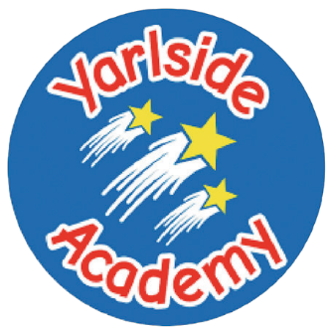
Academy
Fish goujons
served with chips and peas
or Jacket Potato served with beans/cheese/tuna
or Vegetable fingers

Dessert
Carrot cake

Baked sausages
served with roast and creamed potatoes, farmhouse vegetables and gravy
or Jacket Potato served with beans/cheese/tuna
or Vegetarian sausages
Dessert
Cheese and crackers

Chicken breast burger
served in a bun with salad and coleslaw
or Jacket Potato served with beans/cheese/tuna or Vegetable burger
Dessert
Ice cream and peaches

Deli bar will be available daily which includes breads, meats, salad, pasta and vegetables-This is available as an alternative main course option

A smart sweet treat selection will be available daily as an alternative dessert option which may include fruit and yoghurt

Allergen information available upon request

Daily Alternatives

Week Yarlside
3

Meat Free Monday

Street Food Wednesday
Chip Shop Friday

Around the World Tuesday
Traditional Thursday
Seasoned chicken wrap
served with savoury rice
or Jacket Potato served with beans/cheese/tuna
or Seasonal vegetable wrap

Dessert
Fruit jelly and watermelon

Tomato and herb pasta bake
served with salad and garlic bread
or Jacket Potato served with beans/cheese/tuna

Dessert
Frozen fruit yoghurt

