
UNIFORM POLICY

Yarlside Academy

Approved by: Local Academy Committee
Chair | Tim Clark
Signed:
Date: | June 2025
Chief Executive Officer | Simon Laheney
Signed:
Date: | 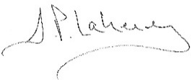  June 2025

Policy Owner: | Headteacher
Implementation Date | Summer 2025
Review Date: | Summer 2026

School Uniform
At Yarlside Academy, we have very high expectations of our pupils and their personal presentation. It is our expectation that every pupil is ready to learn and wearing full uniform shows the ambitious standards and pride we feel about our school community. All students should wear school uniform to and from school, during the school day and when participating in school-organised events. It encourages a sense of belonging, an identity and ensures equality for all students.
When you accept a place for your child at Yarlside Academy, you agree to support the school's Uniform Policy through the Home to School Agreement. The elements of the Uniform Policy are non-negotiable, and the school retains the right of final decision on any issue pertaining to this policy.
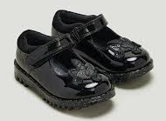
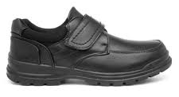
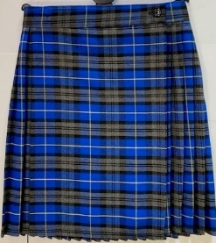
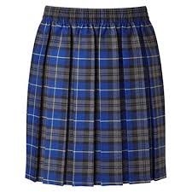
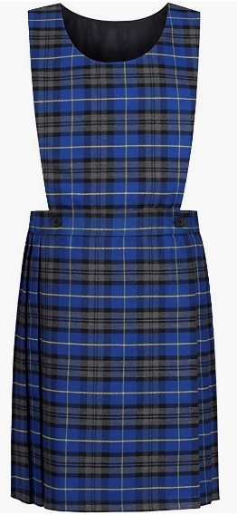
School Uniform
Tartan pinafore Tartan Pleated Skirt Tartan Kilt Sensible Black Shoes
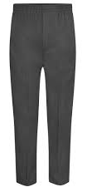
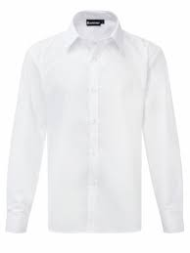
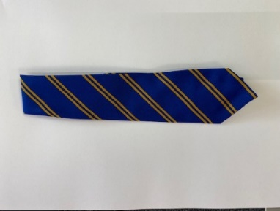
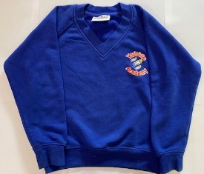
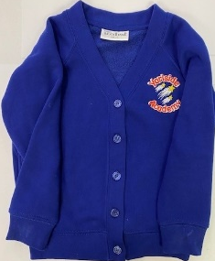

Grey Trousers Royal Blue Cardigan Royal Blue Sweatshirt White Shirt Tie


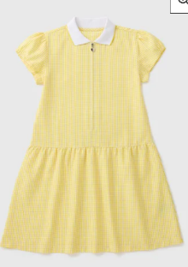
Summer Uniform
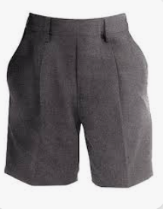
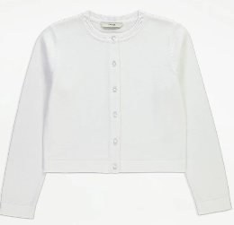
Yellow gingham dress White cardigan Grey shorts Royal blue polo shirt
with logo

Nursery
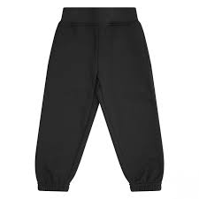
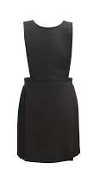
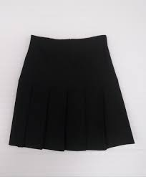
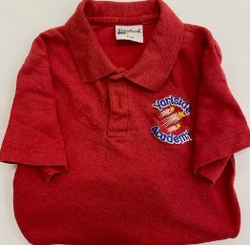
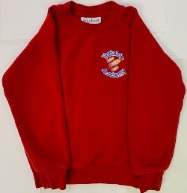
Red Sweatshirt Red Polo-Shirt Black Skirt Black Pinafore Black Joggers
If pupils come to school wearing trainers, parents must contact school to discuss the reason why. Shoes must be replaced the following day.

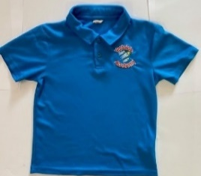
PE Kit
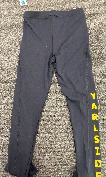
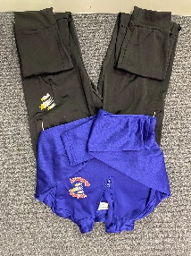
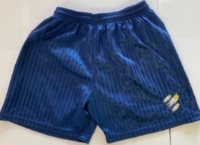
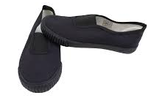

Royal Blue PE Top Blue PE Shorts Optional Tracksuit Optional Girls Plimsols/Trainers
PE Leggings

PE Policy: Should, for any reason, a student be unable to participate in the lesson they are expected to change into their full kit as they will be required to coach, observe and contribute verbally during the lesson.

In cases where pupils do not follow or comply with the above uniform policy, parents will be contacted and supported where necessary to ensure that their children are quickly able to meet the uniform requirements of the school.

Purchasing Uniform

The Yarlside Academy Uniform and PE Kit can be obtained from:
- Identity - click here
- Cumbria School Uniforms - click here
- My Clothing - click here
- Other suppliers (supermarkets, clothing stores) where the logo is not required

For second hand uniform purchases:
- St. Mark’s Clothes Bank (Barrow)
- The school office (please call first to check availability)

For second hand uniform donations:
- St. Mark’s Clothes Bank (Barrow)
- The school office

Hair
Yarlside will not accept extreme hair colours.
- Shoulder length hair must be tied back

Make up
Students are not allowed to wear make-up.

Jewellery
Students in school are restricted to wear:
- A watch, ‘Smart’ watches are not allowed
- one pair of studs for pierced ears (only one in each ear lobe).
- Necklace/bracelet for religious or medical reasons

For health & safety reasons, all jewellery must be removed before a PE lesson.

SCHOOL EQUIPMENT
All other equipment, including writing implements will be provided by school.

